**PROJECT REPORT TEMPLATE**

***Political Juggernaut:***

***A Quantitative Analysis Of Candidates In The 2019***

***Lok Sabha Elections***

**INTRODUCTION:**

The “Lok Sabha Analysis 2019” aims to examine and interpret various aspects of the 2019 Indian general elections, focusing on parliamentary constituencies, voter demographics, key issues, and political trends. Through data analysis and visualization, the project seeks to provide insights into the electoral dynamics and outcomes of this crucial democratic exercise in India.

**PURPOSE:**

The Lok Sabha elections in 2019 in India were held to elect members of the lower house of the Parliament. The purpose was to form a new government and determine the political representation based on the democratic mandate of the Indian citizens. The Bharatiya Janata Party(BJP) by Narendra Modi secured a significant victory in these elections, and as a result, Modi continued as the Prime Minister of India.

**2 PROBLEM DEFINITION AND DESIGN THINKING:**

2.1 Empathy map

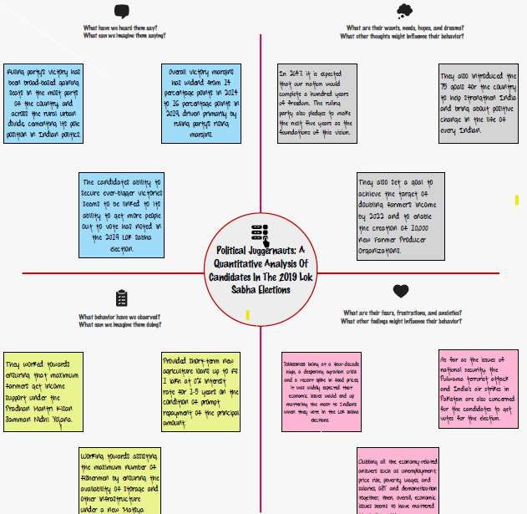

2.2 Ideation and Brainstorming

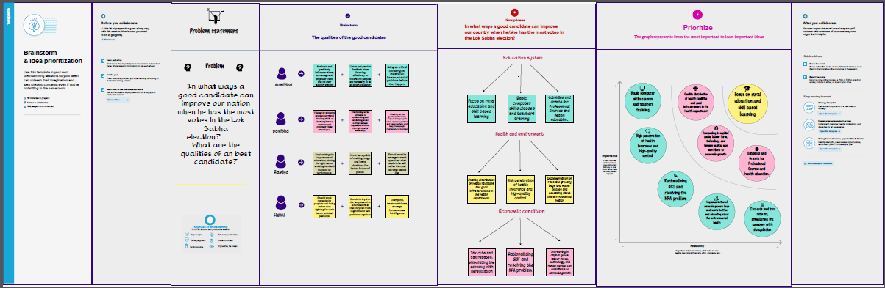

3. RESULT:

We create the data visualization such as dashboard and story using the dataset provided

Dashboard:

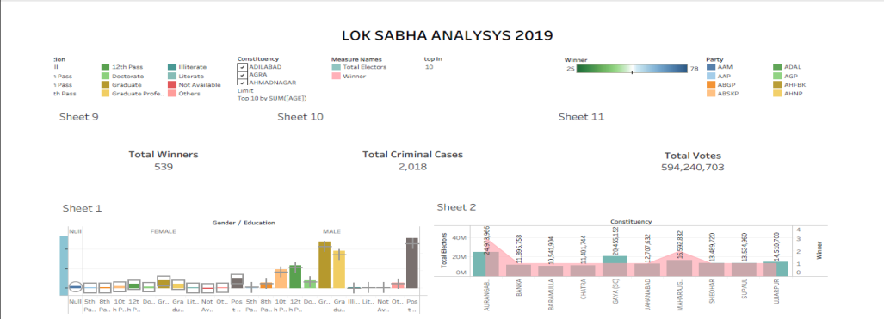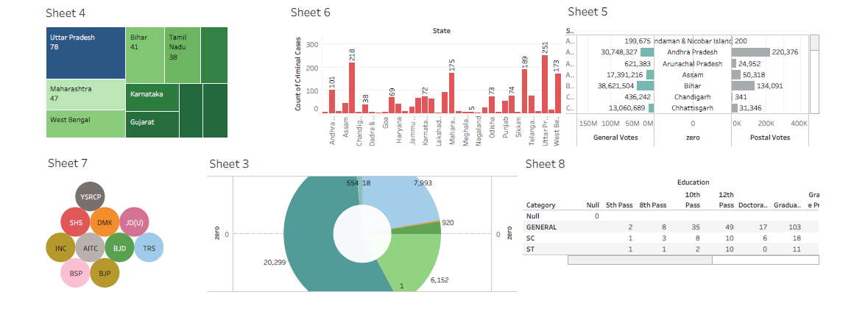

Story:

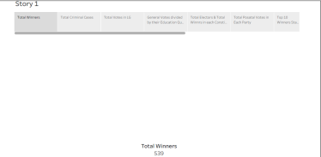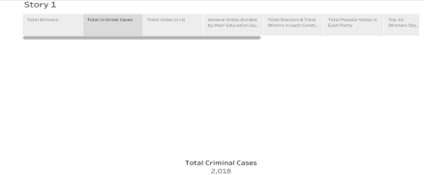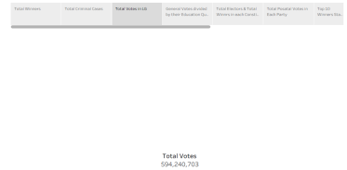

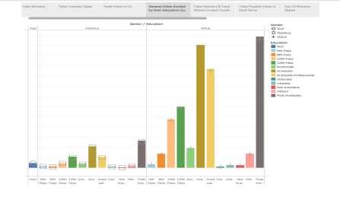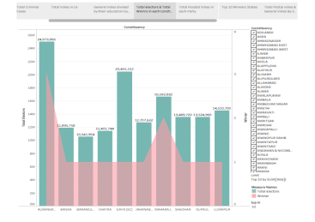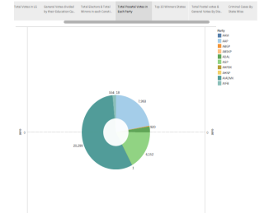

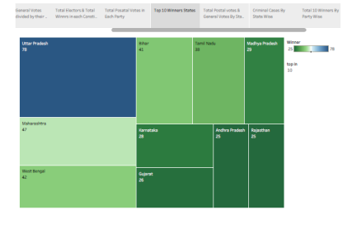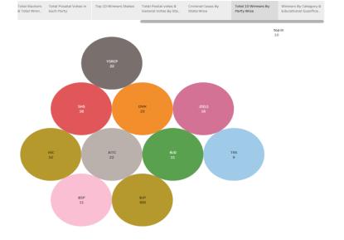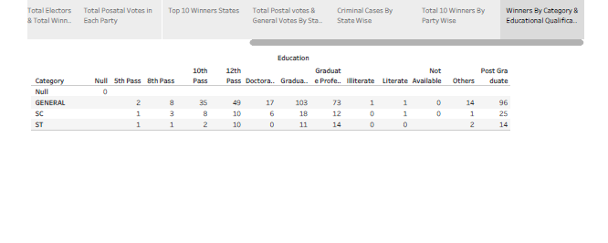

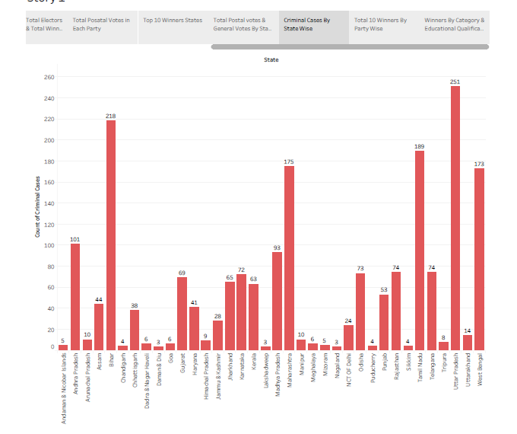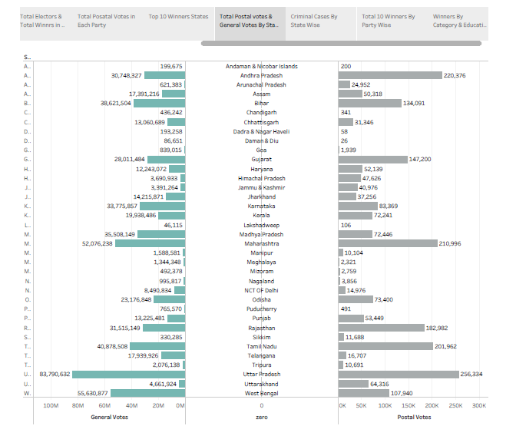

4. ADVANTAGES AND DISADVANTAGES

**ADVANTAGES:**

* DEMOCRATIC REPRESENTATION:

The elections allowed for the democratic representation of the people’s will, ensuring that citizens had a say in the formation of their government.

* POLITICAL STABILITY:

The decisive outcome contributed to political stability, as a clear mandate enabled the government to pursue its agenda with greater certainty.

* CONTINUITY OR CHANGE:

Depending on one’s perspective, the elections offered the opportunity for either the continuity of the existing government or a change in leadership, reflecting the diverse opinions of the electorate.

* PARTICIPATION:

The elections encouraged civic participation and management, with millions of citizens exercising their right to vote.

**DISADVANTAGES:**

* POLARISATION:

The elections highlighted political polarization, with intense debates and divisions among the electorate, potentially leading to social tensions.

* ECONOMIC IMPACT:

Political uncertainty during elections can sometimes have economic repercussions, affecting investorconfidence and economic stability**.**

* ELECTORAL EXPENDITURE:

Elections often involve significant financial expenditure, raising concerns about the influence if money in politics and the need for campaign finance reform.

* REPRESENTATION ISSUES:

* Despite being a democratic process, concern about the representation of marginalized or under represented groups may persist, highlighting the need for continued efforts to ensure inclusivity.

* It’s important to note that the advantages and disadvantages can be subjective, varying based on individual perspectives and political ideologies.

5.APPLICATIONS**:**

The Lok Sabha elections of 2019 in India had several significant applications:

* GOVERNMENT FORMATION:

The primary application was the formation of a new government at the national level. The party of coalition that secured the majority of seats in the Lok Sabha got the mandate to form the central government.

* POLICY DIRECTION:

The elections determine the policy direction of the country. The winning party or coalition’s manifesto and campaign promises influenced the policies and initiatives implemented during their tenure.

* LEADERSHIP CONTINUITY OR CHANGE:

The outcome decided whether there would be a continuity of leadership or a change in the Prime Minister and the central cabinet, influencing the overall governance structure.

* REPRESENTATION OF DIVERSE VOICES:

The elections were a means for diverse voices and opinions across the country to be represented in the national decision-making process. Members of Parliament from various and communities contributed to shaping policies that affected the entire nation**.**

* LEGISLATIVE AGENDA:

The Lok Sabha, as the lower house of the Parliament, played a crucial role in the passage of legislation. The composition of the Lok Sabha after the 2019 elections determined the legislative agenda and the ability to pass laws.

* FOERIGN RELATIONS:

The election outcome had implications for Indian’s foreign relations. The government’s stance and approach on international issues were influenced by the political ideology and foreign policy priorities of the ruling party or coalition.

* ECONOMIC IMPACT:

The policies and decisions taken by the government based on the election mandate had a direct impact on the country’s economy, influencing factors like investment, trade, and overall economic growth.

6. CONCLUSION

**Define problems\problem understanding**

* **Specify the business problem**
* **Business requirements**
* **Literature survey**

**Data collection&extraction**

* **Connect dataset with tableau**
* **Collect the dataset**

**Data preparation**

* **Prepare the data for visualization**

**Dashboard**

* **Responsive and design of dashboard**

**Story**

* **No of scenes of story**

**Performance testing**

* **Utilization of data filters**
* **No of visualization\graphs**

**Project demonstration and documentation**

* **Record explanation video for project end to end solution**

**By this we conclude our project.**

**7. FUTURE SCOPE:**

**The Lok Sabha elections of 2019 have already had a profound impact on India’s political landscape, but their future scope lies in the continued influence on various aspects of governance and society:**

1. **POLICY IMPLEMENTATION:**

**The policies outlined by the government based on the 2019 mandate will continue to be implemented, affecting areas such as economic development,social welfare,and governance structures.**

**2. INFRASTRUCTURE DEVELOPMENT:**

**The government elected in2019 outlined ambitious plans for infrastructure development. The future will see the realization of these projects,contributing to economic growth and improved living standard.**

**3.FOREIGN RELATIONS:**

**The foreign policy apporach set during this period will shape India’s relations with other countries in the coming years, influencing diplomacy ,tradeagreements, and international collabarations.**

**4.SOCIAL AND CULTURAL INITIATIVES:**

**The government’s initiatives to address social issues and promote cultural programmes will likely continue, impacting societal norms,values,and cultural development.**

**5. ECONOMIC REFORMS:**

**The government elected in 2019 aimed at implementing economic reforms. The future will reveal the success and long – term impact of these reforms on area such as taxation,business environment , and financial regulations.**

**6.TECHNOLOGICAL ADVANCEMENTS:**

**The government’s stance on technology ,digital governance ,and innovation will influence India’s trajectory in the global technological landscape.**

**7.ENVIORNMENTAL POLICIES:**

**Initiatives and policies related to environmental conservation and sustainable development ,outlined by the government,will have future implications for India’s ecological well-being.**

**8.SOCIAL JUSTICE AND INCLUSIVITY:**

**Efforts to address issues of social justice and inclusivity including affirmative action policies and social welfare programs, will likely continue to be part of the government’s agenda.**

**9.HEALTHCARE AND EDUCATION:**

The emphasis on healthcare and education, especially in response to challenges like the COVID-19 pandemic, will shape the future landscape of public health and education in the country.